**GUVI FULL STACK JAVA**

Online Bus Ticket Booking System

How to Setup-

1. To setup the project application follow the path follow given below:

File > New > Other > Select a wizard>Spring Boot>Spring Starter Project

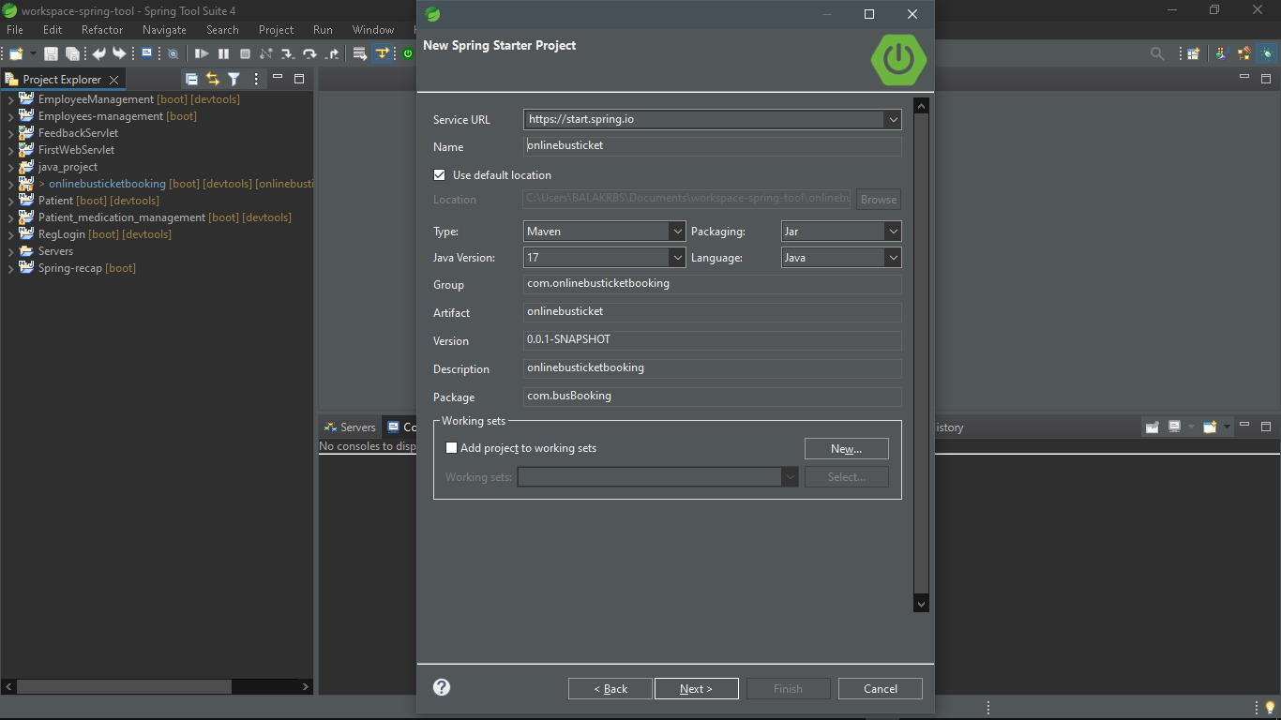

1. Adding required dependencies for the project:

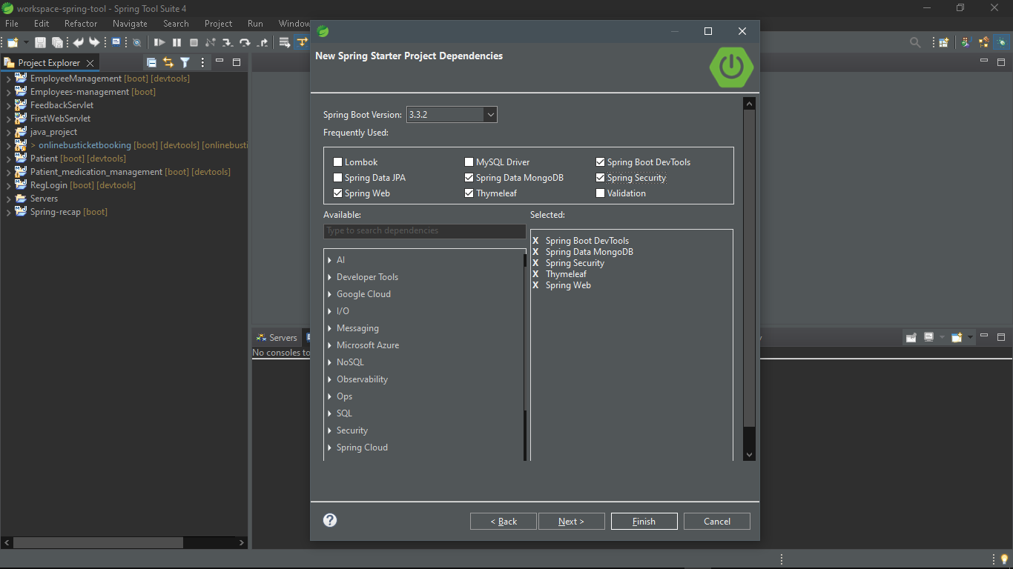

1. Now we have the “Online Bus Ticket Booking System” Spring boot project.

src/main/java – has the all java files for Back-end

src/main/resources/static – has the all css, images files for Front-end

src/main/resources/templates – has the all html files for Front-end

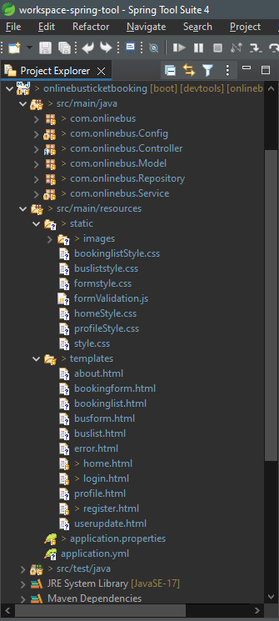

How to Run-

Follow the below path:

OnlineBusTicketBooking > Left click > Run As > Spring boot app

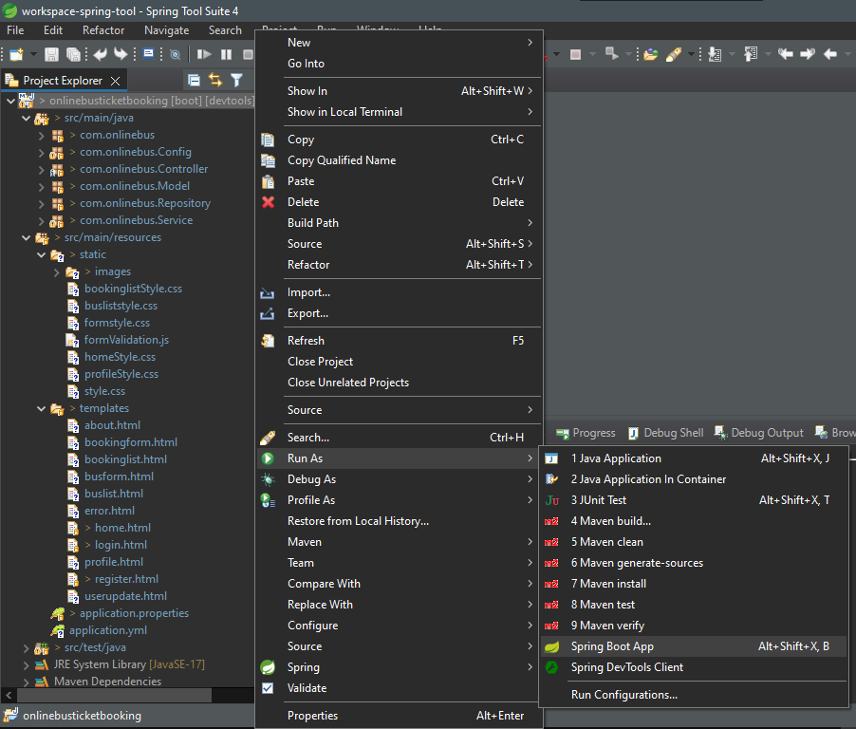

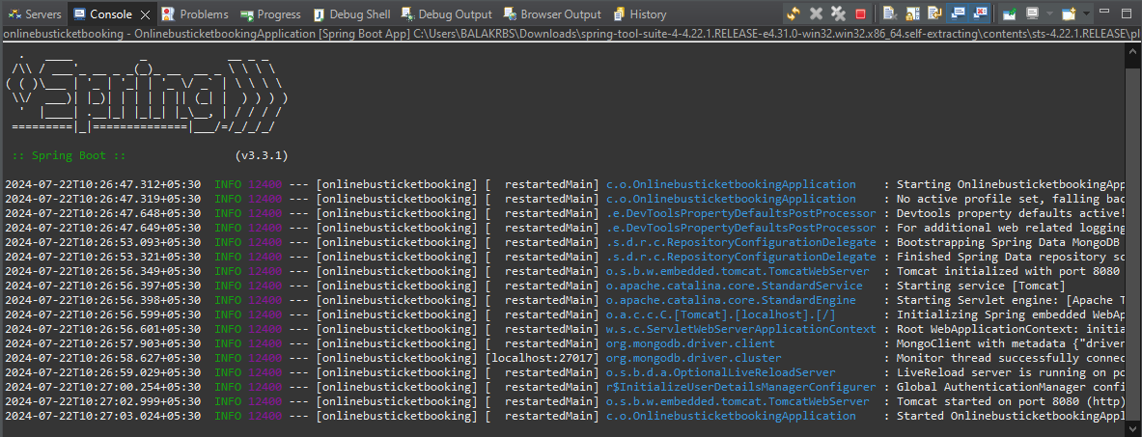

Browser:

Enter the localhost:8080 in the brower url Tab.

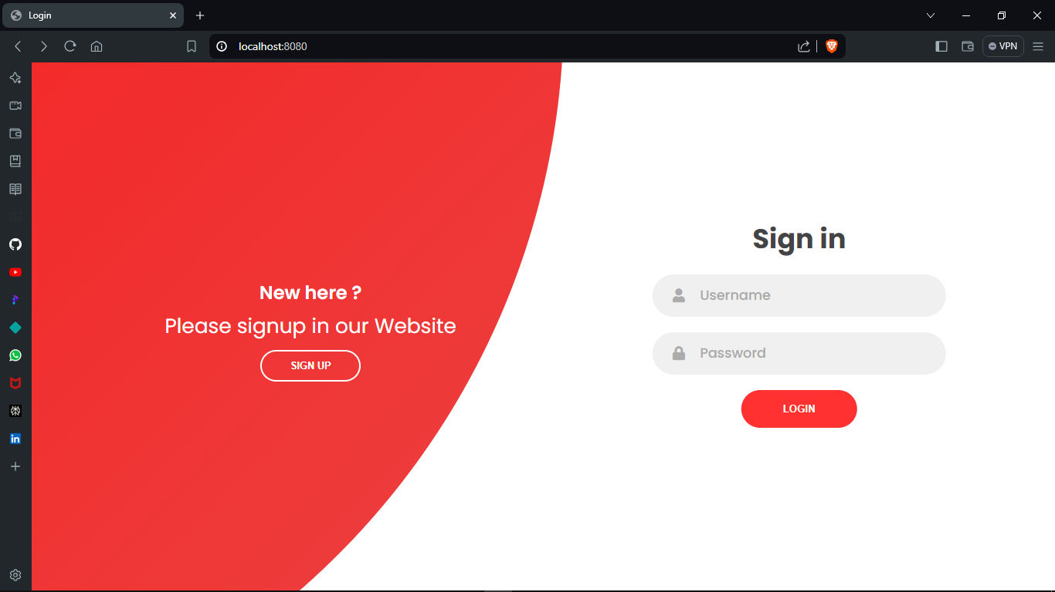

This Application.properties has the server port, database url, application name and other properties.

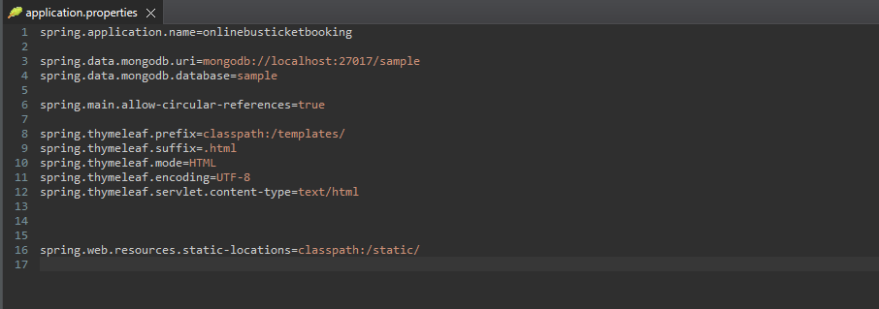

Add the Mockito dependency for the unit test

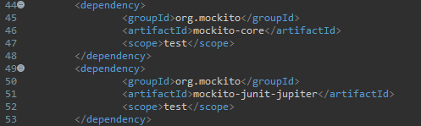

This is Xml file has the All Dependency of the project.

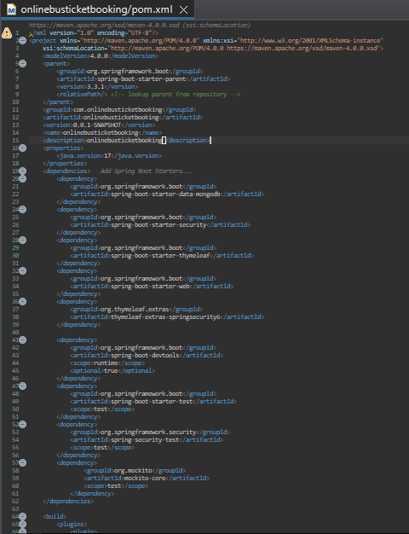

Com.onlinebus

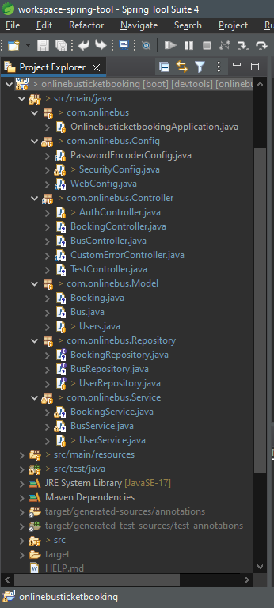

Back-End Packages:

-Model

-Service  
-Repository

-Controller  
-Configuration

* Model:
* Users
* Bus
* Booking
* Service:
* UserService
* BusService
* BookingService
* Repository:
* UserRepository
* BusRepository
* BookingRepository
* Controller:
* AuthController
* BusController
* BookingController
* CustomErrorController
* TestController
* Configuration:
* SecurityConfiguration
* PasswordEncoderCofiguration
* WebConfiguration

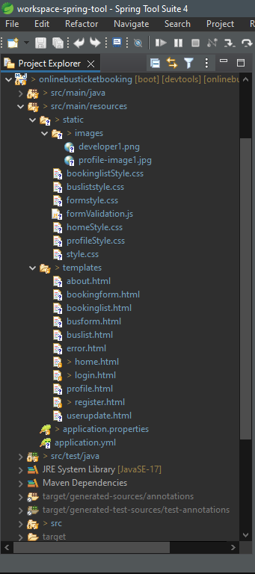

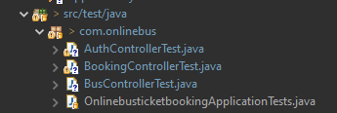

Front-End Packages:

* **Static**
* Images
* Css file
* Login/SignupStyle
* HomeStyle
* FormStyle
* BuslistStyle
* BookingListStyle
* ProfileStyle
* Javascript
* FormValidation
* **Templates**
* Html
* Login
* Register/signup
* Home
* BusForm
* BusList
* BookingForm
* BookingList
* Profile
* UserUpdate
* Error

Unit test Packages:

* User/Authentication
* Booking
* Bus

Screenshots :

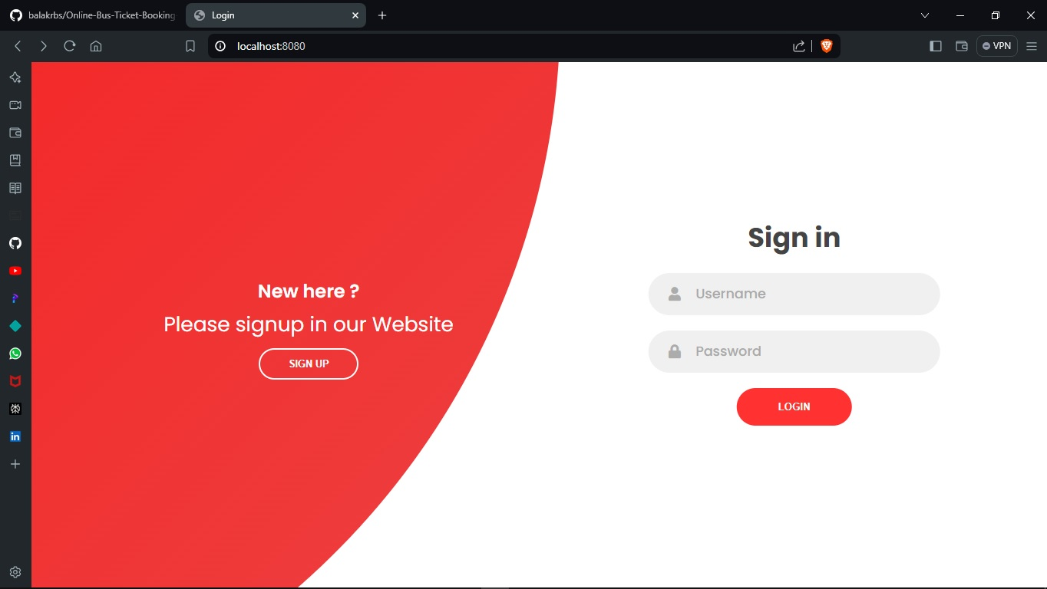

Login emails and password (stored in database)

[balakrbs -](mailto:rahul@gmail.com%20-%20rahul) krbs

[home](mailto:cardi@gmail.com) - home

